Name_______________________________ GT Bio
Drosophila melanogaster Lab
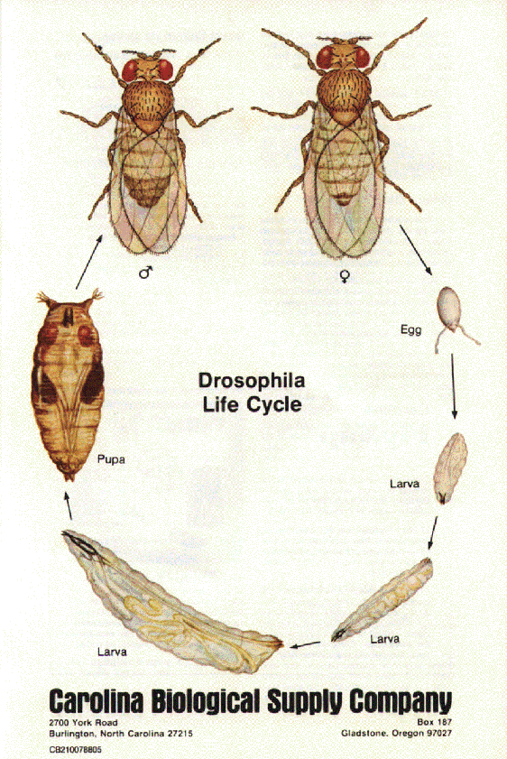
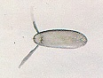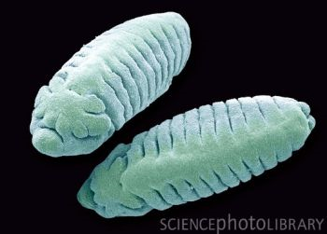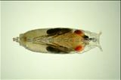

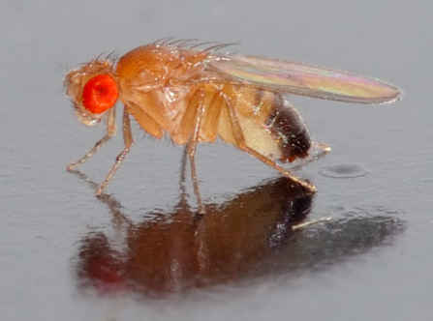

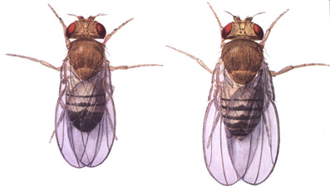

Chromosomes:

Mating behaviors:

Wild type flies Vestigal
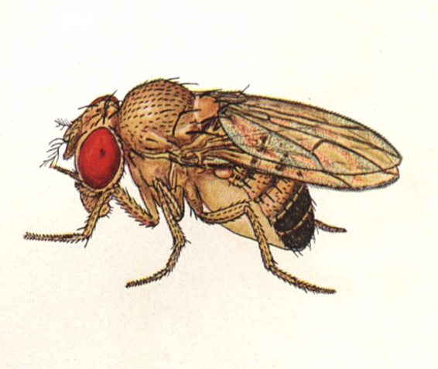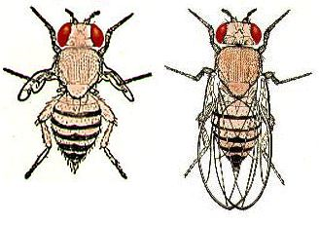
Lab materials( what and why)
tubes-
petri dish-
paintbrushes-
yeast-
formula blue food-
sponge cork-
fly nap-
How to put flies to sleep-

Fly trap-

Fly jar-

Stereoscope
